1a)

1b)

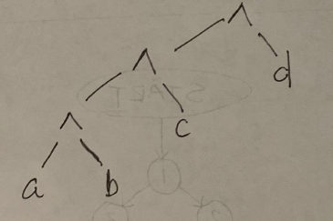

1c)

1d)

2)

3)

4)

5)

